HOW TO ACCESS YOUR I-94 NUMBER AND INFORMATION

**What is the I-94 used for?**

Effective 4/30/2013, the I-94 paper record will now be made electronically at the border and the paper I-94 card will no longer be issued for most people traveling by air or sea.

You should access your I-94 Admission Record online at [www.cbp.gov/i94](http://www.cbp.gov/i94) after entering the country; check as soon as possible to see that all of your personal information is correct, and print a copy to keep with your immigration documents as proof of your current status in the U.S. Be prepared to present this printed copy of your I-94 when applying for a Social Security Number or driver's license and when completing an I-9 Form for employment. There may be other instances in addition to those just mentioned when you'll be asked to present this printed information.

Paper I-94 cards will still be distributed at land borders with Canada and Mexico. If you entered the country more than 2 years ago, your I-94 record will not appear in the online system at this time; your current I-94 card will remain valid.

**How do I access my I-94 information?**

Go to [www.cbp.gov/I94](http://www.cbp.gov/I94) on your computer, and enter in the requested information.

For help, and for more information on the I-94, access the “I-94 FAQ” page of the website; or, feel free to ask an International Student Services advisor for help.

Below is a sample of the I-94 printout from the site after you enter your information:

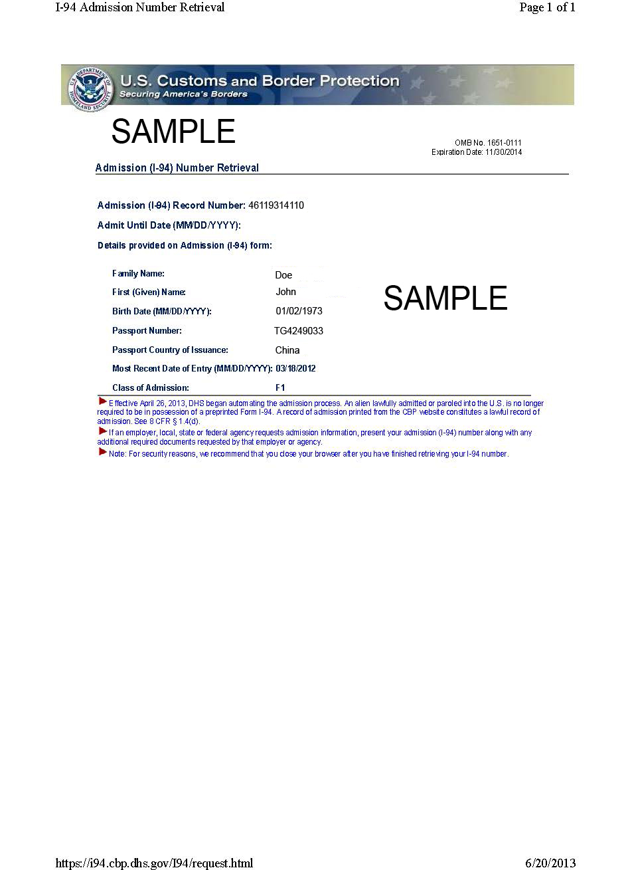

If you cannot access your I-94 information, and have been in the United States at least 10 days, please contact the US Customs and Border Protection office in Cleveland at (216) 267-3600, and select option 2. They will attempt to fix your situation over the phone, or will make an appointment if necessary.